Checker Wars

Project Description Summary

**Group 16: Alex Choi, Andrew Macatangay, Sam Alammar, Luke Austin**  
CS 440  
University of Illinois Chicago

The project description report for Checker wars encompasses the project overview, the purpose of the project, the scope of the work, the scope of the product, the stakeholders involved, any mandated constraints, any naming conventions and definitions, and any relevant facts and assumptions related to the project.

Checker Wars is a new, virtual take on the game of Checkers being developed by Bohn Jell Entertainment (BJE) to entertain game players and provide a new avenue for online competitive game play. The purpose of Checker Wars is to create a new, entertaining game for consumers, and to carve out a chunk of the ever-growing video game and e-sports scene for BJE.

The total esports revenues for 2018 was estimated at $805 million US dollars and has been growing every year since measurements began. Currently esports are a small portion of the overall sporting revenues worldwide, but they are gaining traction, legitimacy, and funding every year, and are projected to eventually take over in popularity from traditional sports.

Checker Wars is not alone in this space. There are many competitive online games in this space, with traditional chess via chess.com being one of the most popular. Checker Wars plans to fit into this niche and convert some new players to online competitive play, as well as some current chess.com and other game players who stream via twitch.tv to the Checker Wars family.

Checker Wars is a 4-Dimensional version of the game of Checker with some additional elements. In the image below, the white dots represent the pawns, the triangles represent the guardsmen, and the squares represent the nobles. The K spaces represent king spaces, the T spaces represent towers, and the S spaces represent summon spaces.

Each player’s turn is determined by the roll of two die. The player with the highest roll goes first and has the sum of their roll in ‘moves’ to move their pieces. This player gets to decide whether the order of turns goes clockwise or counterclockwise from them. Pieces attack other pieces by jumping over them and can chain attacks by jumping over successive pieces in the same turn, while only using up one ‘move’. A win is determined when either three towers are captured by one army, or if the other players have no more pieces.

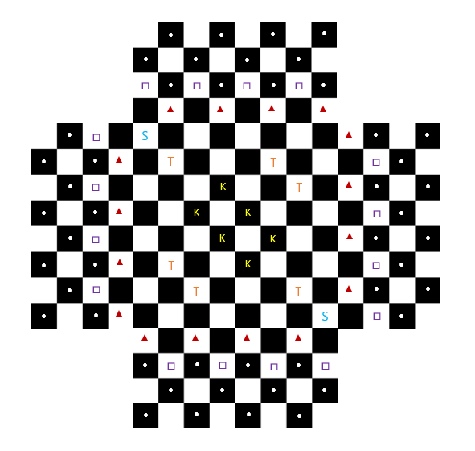

Checker Wars is being designed, produced, and also for some parts such as the graphics, commissioned by BJE. Checker Wars is aimed at teen and young adult players who have the most free time to spare for games, but appeals to players of all ages because of it’s intuitive play and similarities with the game of checkers.

BJE will be pursuing financial relationships and support from PC peripheral manufacturers such as Razer and Logitech, as well as venture capital funds to raise capital to produce the game.

Checker Wars will be first developed as a web application through checkerwars.com. Once the minimum viable product has been made and proven as a web app, the game will move into development for specific platforms, including Windows, MacOS, iOS, and Android.

The game will be programmed in an object-oriented language such as Java, C++, or Python, and will only take up a small amount of space when complete (20-30MB). It will require user to have at least 2GB+ or RAM, and a modern processor/device to run the game optimally.